A1 Investigation and Planning
Problem Statement
The Scholarship Office currently manages scholarship renewal using spreadsheets, email attachments, and paper-based grade records. This manual process results in duplicate semester submissions, unverified academic records, delayed evaluations, and inconsistent renewal decisions. Scholars also have limited visibility regarding the status of their submissions. A browser-based Scholarship Monitoring System is proposed to streamline submission, verification, evaluation, and renewal processes while maintaining the Registrar as the official source of grades.

Problem – Cause – Effect Analysis
Problem | Cause | Effect
Duplicate semester submissions | No system validation for duplicate records | Multiple records for the same semester causing confusion during evaluation
Unverified academic records | Grade documents are submitted through email without a verification workflow | Staff cannot easily determine whether submitted evidence is authentic
Delayed scholarship renewal | Manual checking of spreadsheets and paper documents | Slow processing of scholarship renewal decisions
Scholars cannot monitor application status | No centralized tracking system | Scholars repeatedly ask staff for updates and may miss correction deadlines

Project Scope
The Scholarship Monitoring System will allow scholars to submit semester academic summaries and grade-document references. Scholarship Staff can register scholars, assign scholarship programs, verify submitted evidence, evaluate compliance based on scholarship policies, record renewal decisions, and maintain decision history. The system also provides dashboards, search, filtering, and role-based access control.

Project Exclusions
- Editing official grades maintained by the Registrar
- Scholarship payment processing
- SMS or email notification services
- Appeal or reconsideration workflow
- Integration with the Registrar's live information system
Development Tasks
- Design the database schema and configure authentication with role-based access.
- Develop the scholar submission module with validation and duplicate prevention.
- Develop the staff verification, compliance evaluation, and renewal modules.
- Test the system using the required examination test cases and correct identified defects.
Risk and Mitigation
Risk | Response / Mitigation
Internet or hosting failure during the examination | Prepare a fully functional local version with complete setup instructions and database backup.
Insufficient development time | Prioritize the mandatory features first before improving the user interface or adding optional enhancements.

A2 Stakeholders and elicitations
Stakeholders | Role in the System | Actual Actor
Scholar | Submits semester academic summaries, views submission status, and resubmits returned submissions. | Yes
Scholarship Staff | Registers scholars, assigns scholarship programs, verifies evidence, evaluates compliance, and records renewal decisions. | Yes
Registrar | Provides the official academic grades used as the reference for verification. The Registrar does not directly use the system. | No
Scholarship Office Administrator | Oversees scholarship operations, policies, and reporting but does not perform the day-to-day system transactions. | No

Open-Ended Elicitation Questions
- How do Scholarship Staff currently verify whether the submitted grade document is valid before evaluating a scholar's renewal?
- What should happen if a scholar submits the required documents after the official submission deadline?
- Under what circumstances can a scholarship policy or renewal decision be overridden or treated as an exception?
- What information should scholars and Scholarship Staff be allowed to access based on their respective roles?
- What reports or dashboard summaries are most useful for monitoring scholarship submissions, verification, compliance, and renewal decisions?
- How should the system handle returned submissions, corrections, and resubmissions to ensure that all changes are properly recorded and tracked?

A3 Requirement and Rules

Functional Requirements
ID | Functional Requirement
FR01 | The system shall allow registered scholars to log in securely using their assigned accounts.
FR02 | The system shall allow Scholarship Staff to register scholars and assign a scholarship program (Merit Scholar or Community Scholar).
FR03 | The system shall allow scholars to submit one semester academic summary with a grade-document reference.
FR04 | The system shall validate all required inputs and reject duplicate submissions for the same academic year and semester.
FR05 | The system shall allow Scholarship Staff to verify submitted evidence by marking it as Verified or Returned with a reason.
FR06 | The system shall allow scholars to correct and resubmit returned submissions, changing the verification status back to Pending Verification.
FR07 | The system shall evaluate verified submissions using the selected scholarship program's policy thresholds and display compliance results with deficiency reasons.
FR08 | The system shall allow Scholarship Staff to record renewal decisions as Approved or Held. Only compliant submissions may be approved.
FR09 | The system shall provide a dashboard showing total scholars, pending verification, compliant records, and records with deficiencies, with search and filtering features.
FR10 | The system shall maintain a history of verification, evaluation, and renewal decisions, including actor, timestamp, and decision notes.

Non-Functional Requirements
ID | Non-Functional Requirements
NFR01 | The system shall respond to user actions within 2 seconds under normal conditions.
NFR02 | The system shall enforce secure authentication and role-based access using Supabase Authentication and Row Level Security (RLS).
NFR03 | The system shall preserve submitted records after page refresh or system restart.
NFR04 | The system shall provide a responsive interface that is usable on modern desktop and mobile web browsers.

Business Rules

ID | Business Rule
BR01 | A scholar may submit only one academic summary for each academic year and semester combination.
BR02 | Every submission must include a valid grade-document reference before it can be processed.
BR03 | Only Verified submissions may proceed to compliance evaluation.
BR04 | The system shall determine compliance using the policy thresholds of the assigned scholarship program (Merit Scholar or Community Scholar).
BR05 | Only Scholarship Staff are authorized to approve or hold scholarship renewal decisions. Scholars cannot modify renewal decisions.
BR06 | A submission with a With Deficiency evaluation cannot receive an Approved renewal decision.

A4 UML Use Case Modeling
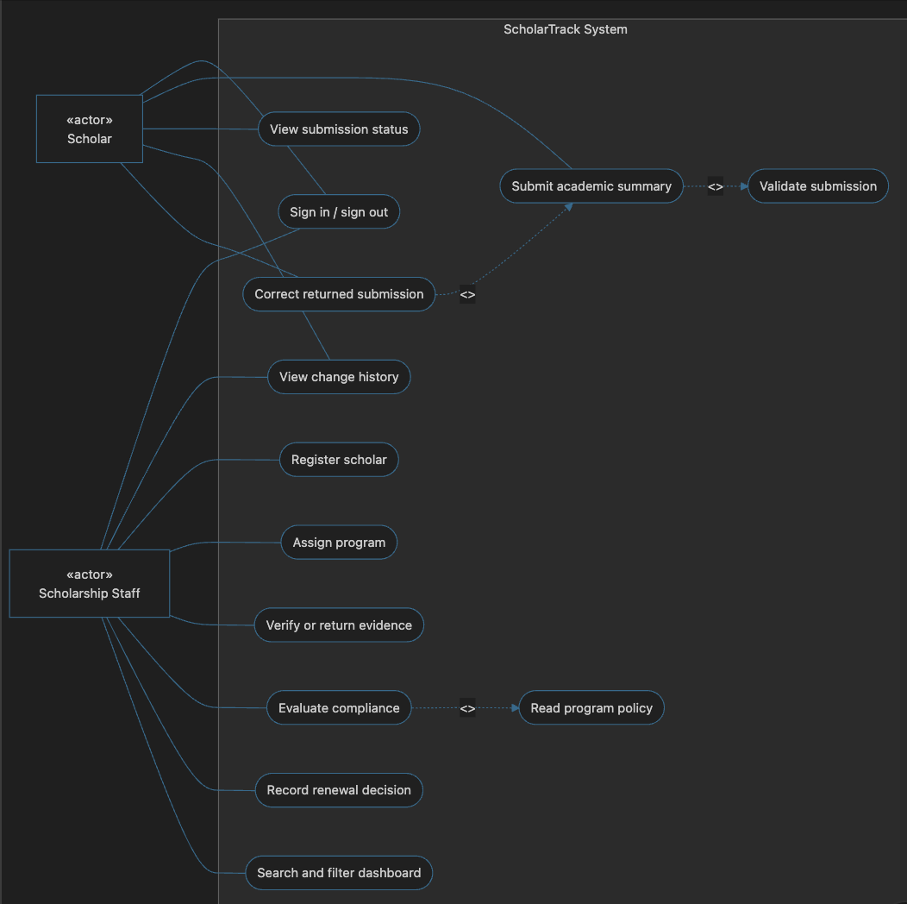

Justification of Relationships

Include Relationship 1

Submit Grades <<include>> Validate Submission

Justification:
Every grade submission must be validated before it is saved. The validation process checks required fields, duplicate semester submissions, valid GWA, and non-negative values. Since validation is mandatory for every submission, an include relationship is appropriate.

Include Relationship 2

Evaluate Compliance <<include>> Check Scholarship Policy

Justification:
Compliance evaluation always requires checking the policy thresholds of the assigned scholarship program (Merit Scholar or Community Scholar). Because this behavior is mandatory whenever compliance is evaluated, an include relationship is used.

Extend Relationship

Resubmit Corrected Submission <<extend>> Submit Grades

Justification:
A scholar only performs a corrected resubmission when the original submission has been returned by the Scholarship Staff. Since this behavior occurs only under a specific condition, it is modeled using an extend relationship.

A5 Detailed Use Cases and Data Design

UC01- Submit Grades

Item | Description
Use Case ID | IC01
Use Case Name | Submit Grades
Primary Actor | Scholar
Trigger | The scholar selects submit grades from the dashboard.
Precondition | The scholar is authenticated and has an assigned scholarship program.
Related Functional Requirements | FR03,FR04,FR06
Related Business Rules | BR01,BR02

Main Flow

- The scholar logs into the system.
- The scholar opens the Submit Grades page.
- The scholar selects the Academic Year and Semester.
- The scholar enters the academic summary (GWA, enrolled units, failed, incomplete, and dropped subjects).
- The scholar enters the grade-document reference.
- The system validates the input.
- The system checks for duplicate submissions.
- The system saves the submission with Pending Verification status and records the timestamp.
- The system displays a successful submission message.

Alternative Flow

A1. If the submission was previously returned, the scholar edits the information and resubmits it.

A2. The verification status automatically changes back to Pending Verification.

Exception Flow

E1. Required fields are missing.

E2. Invalid GWA or negative values are entered.

E3. A duplicate Academic Year and Semester already exist.

The system rejects the submission and displays an appropriate validation message.

Postcondition

The compliance result, renewal decision, decision notes, actor, and timestamp are saved.

Entity Relationship Diagram (ERD)

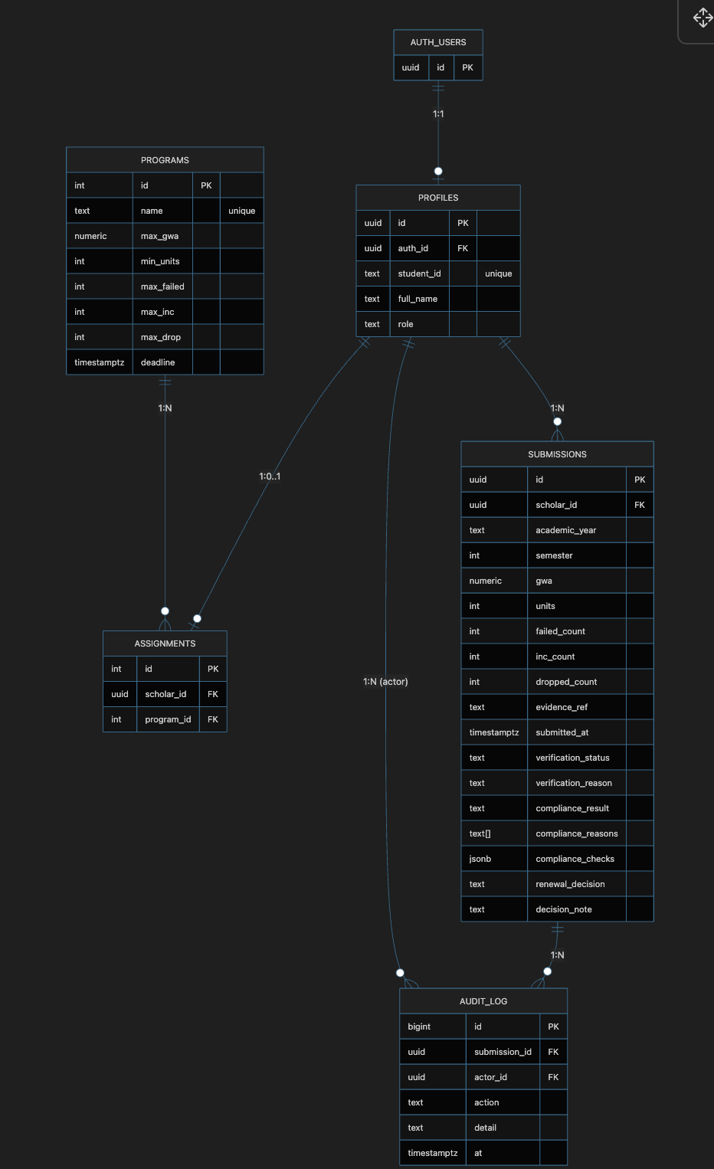

Cardinalities

- One User (Scholar) can have many Semester Submissions.
- One Scholarship Program can be assigned to many Scholars.
- One Scholar Assignment belongs to one Scholar and one Scholarship Program.
- One Semester Submission can have many Evaluation History records.
- One Scholarship Staff can perform many evaluation actions.

A6 Traceability

Requirements Traceability Matrix
Functional Requirements | Actor | Use Case | Business Rule | Implemented Screen / Function | Test Case & Expected Result
FR03 – The system shall allow scholars to submit one semester academic summary with a grade-document reference. | Scholar | UC01 – Submit Grades | BRO1, BRO2 | Submit Grades Page | TC07 – Duplicate semester submissions or invalid input are rejected with a clear validation message.
FR05 – The system shall allow Scholarship Staff to verify submitted evidence by marking it as Verified or Returned with a reason. | Scholarship Staff | Verify Evidence | BR03 | Verification Page | TC09 – A returned submission can be corrected and resubmitted. After resubmission, the status changes to Pending Verification, and the history is preserved.
FR07 – The system shall evaluate verified submissions using the assigned scholarship program policy and display compliance results with deficiency reasons. | Scholarship Staff | UC02 – Evaluate Compliance | BR03, BR04 | Compliance Evaluation Page | TC01–TC06 – The system evaluates submissions according to the selected scholarship policy and displays the correct compliance status and deficiency reasons.
FR08 – The system shall allow Scholarship Staff to record renewal decisions as Approved or Held. Only compliant submissions may be approved. | Scholaship Staff | Record Renewal Decision | BR05, BR06 | Renewal Decision Page | TC10 – Staff can approve only compliant submissions and hold deficient submissions. Scholars cannot modify renewal decisions.

Planned Requirement Not Implemented

The following requirement is identified as outside the scope of this examination and is therefore not implemented:

- Appeal or reconsideration workflow for scholars who disagree with their renewal decision.

- Integration with the Registrar's live information system for automatic retrieval of official grades.

- SMS or email notification services for submission updates and renewal decisions.

These features are documented as future enhancements and are excluded from the current minimum viable system (MVP).

